# Architecture Exercise: SoftUni Blog

Problems for exercises and homework for the ["Node.js & Express.js Fundamentals" course @ SoftUni](https://softuni.bg/courses/express-js-fundamentals)"

## Skeleton

You will be given a skeleton with the **configuration** for your app: user model, user controller, middleware for authentication, all the views and a **package.json** file.

## To-do's and Tips

### Routes

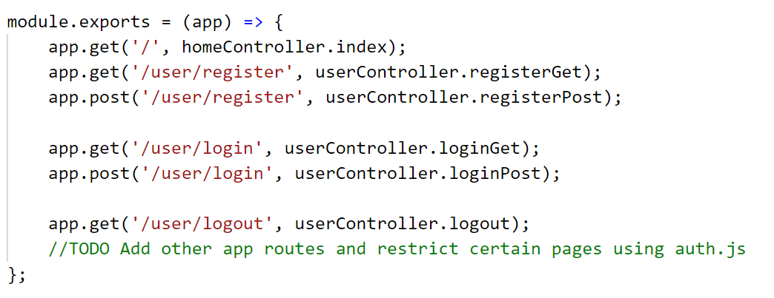

### Home Index

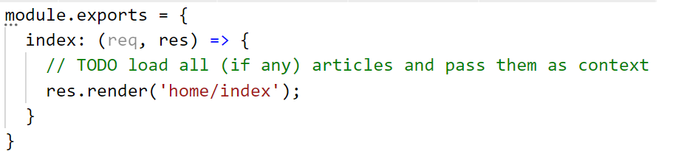

### Layout hbs

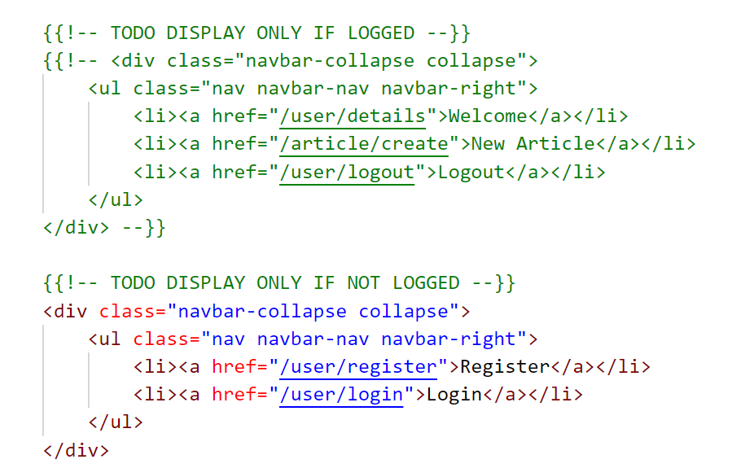

Implement the following routes:

* **/** - load **index.html** file and display the articles (if any)
* **/article/create** – render the create view and make post to create articles
* **/article/details/:id** – render the details page for the selected article
* **/article/edit/:id** – (for admins or authors) render edit view and make post to edit an article
* **/article/delete/:id** – (for admins or authors) render delete view and make post to delete an article

### Models

Create article model with the following properties

* **Title** – string, required
* **Content** – string, required
* **Author** – object ID (user)
* **Date** – date of creation

Update user model

* **Articles** – object ID array (articles)

## Screenshots

### Index Page

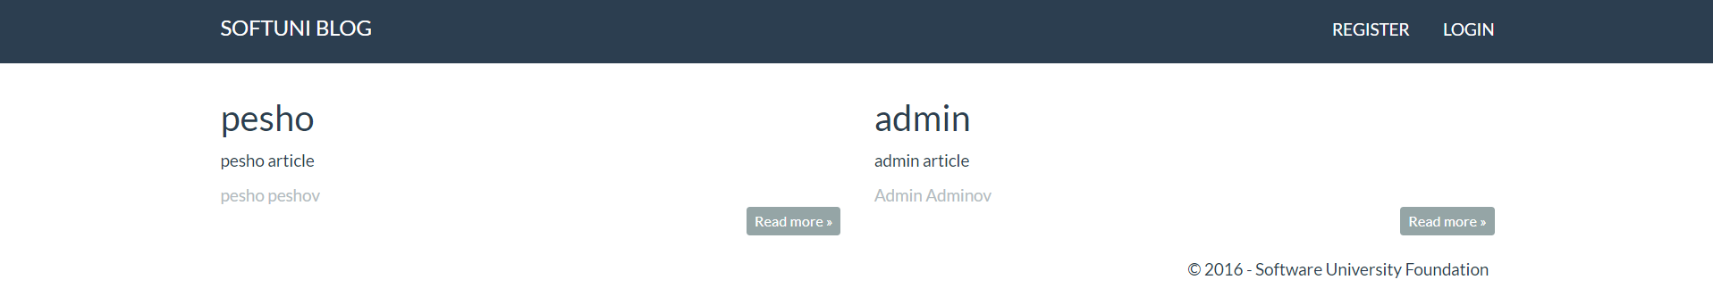

### Register

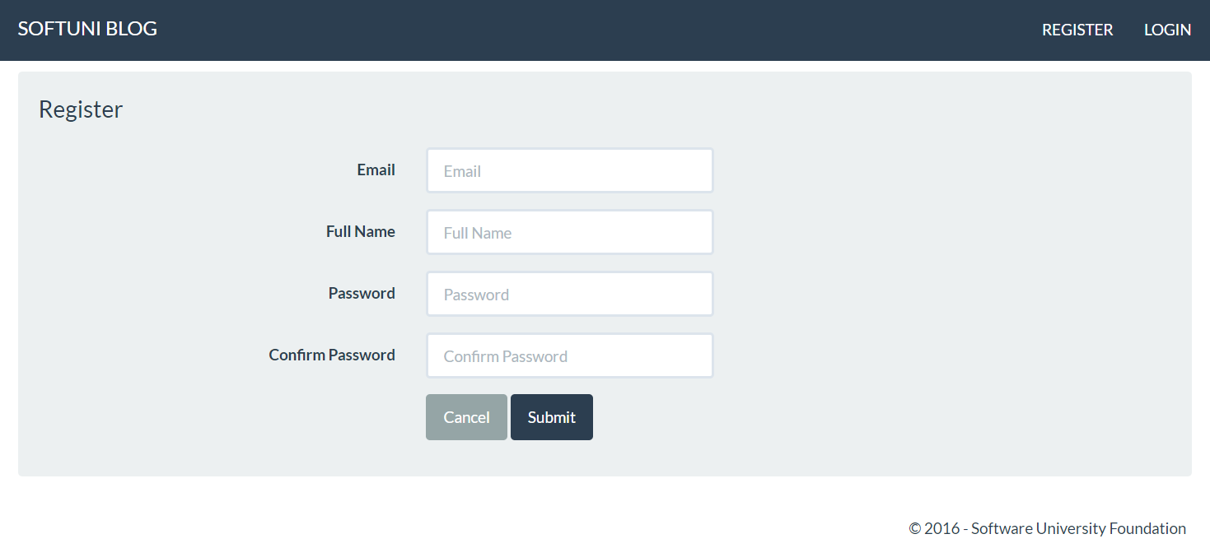

### Login

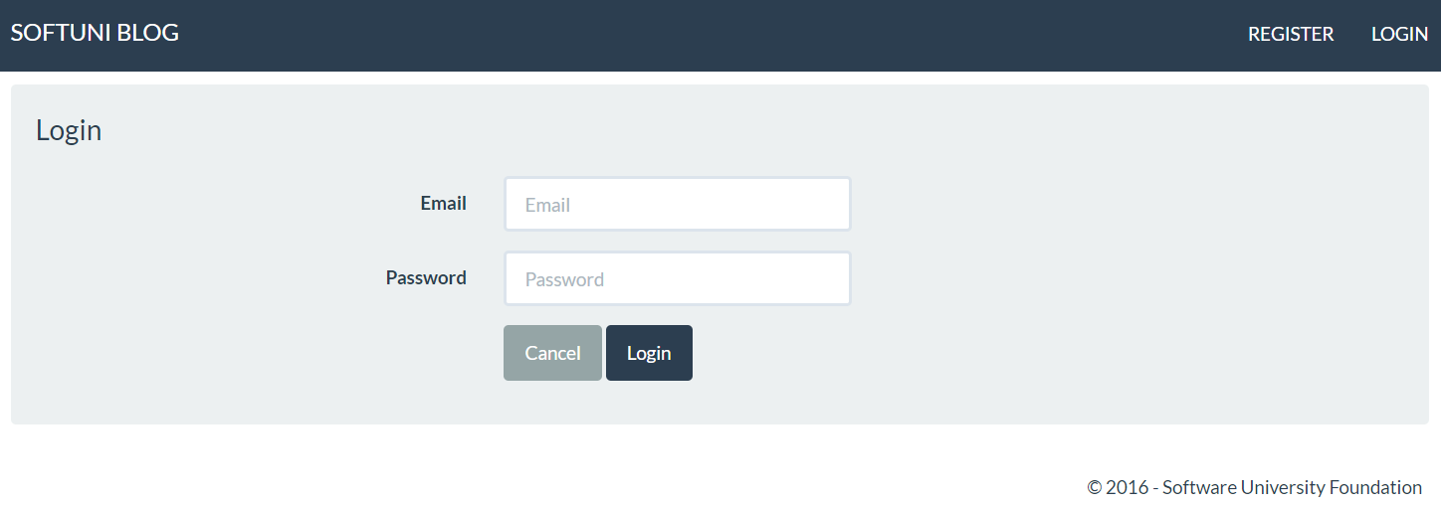

### Details

When admin or author:

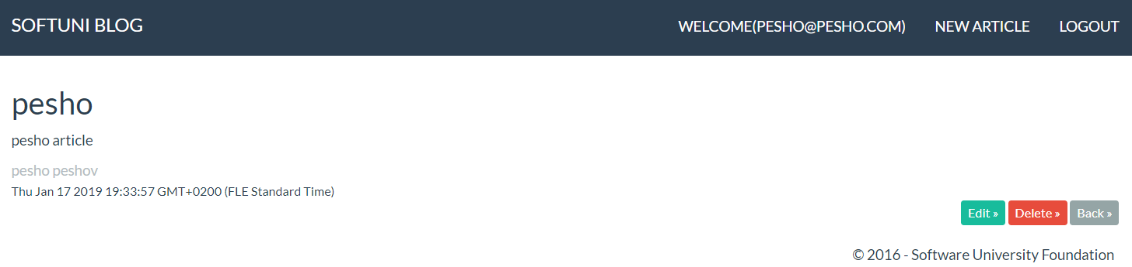

When not admin and not author:

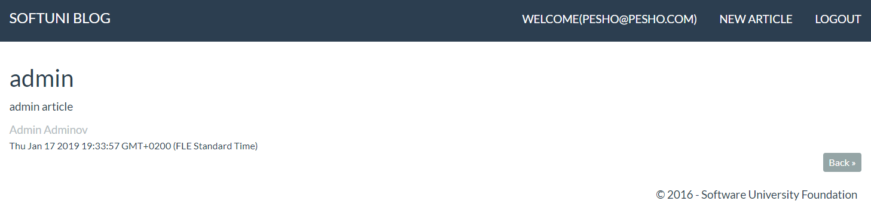

### Edit

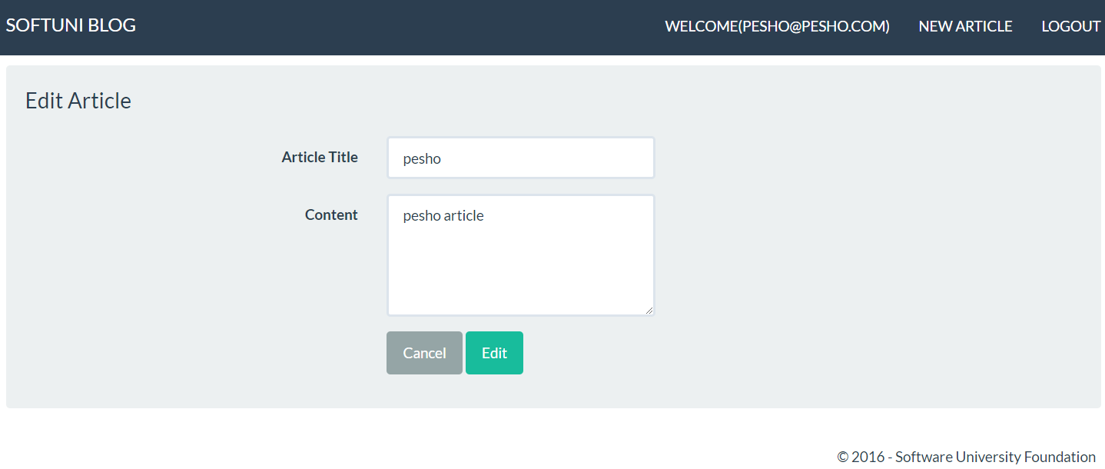

### Delete

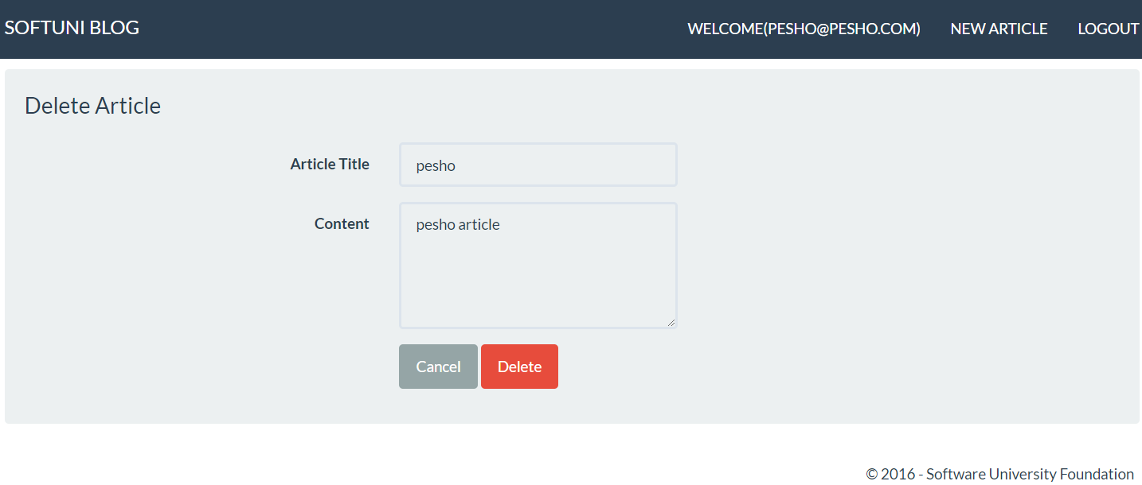

## * Sky is the limit

Add functionality to the blog as you see fit – you may add statistics, image uploads, comments, etc.